Kevin Nunez 00323217 Linux Administration IpTables Adrianna Holden Gouveia 10/25/2026
CentOs Server
Deliverables:
Audience: someone taking care of your servers who hasn’t used iptables before. Assume some technical knowledge but not expertise. Screenshots are helpful to go with your descriptions. Include documents for both servers, clearly labeled with what the document is and which server it’s for.
A text document with your commands, statements, or scripts for each requirement. Include why you chose what you chose, any assumptions you made, and the Wireshark screenshots showing each one works.
Documentation of the iptables rules on each server. Include a list of the changes you made to the chains, which table you changed, and when each change was made. Include a copy of your original rules and your updated rules at the end.
A short document with your DDoS specs, the protection you implemented, and how you tested it, including a detailed explanation of your testing method and screenshots of the results. Cite at least 2 sources.
Explanation of what to do.
First, we are going to need Wireshark to prove the command works and list our iptables.
How to install Wireshark:
We already know that CentOS is a little bit tedious. Let’s start with sudo.
We use su -I or su root and type our password.
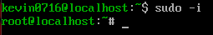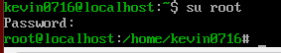

Now let’s start with wireshark
We type the command dnf install wireshark-cli this is just to install Wireshark in the command line because we do not have a GUI.
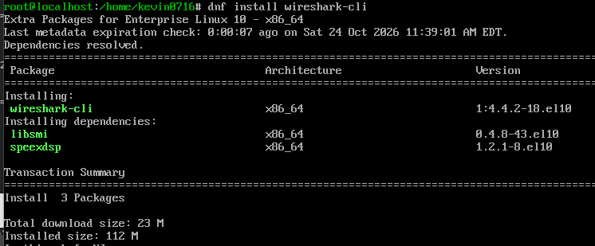
We pressed y

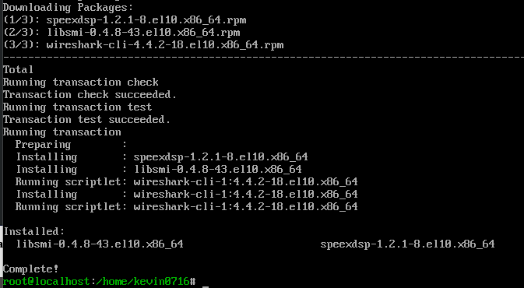

First step completed. Now for the next part of the assignment, we need to list our iptables in the firewall.
The command to see the iptables is iptables -L or iptables –list. It works anyway.
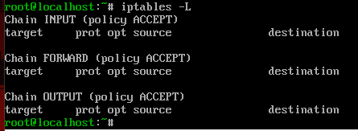
- Deal with web server (open needed ports, and forward port 80 traffic to 8080)
Let’s start with making the transfer from port 80 reaches port 8080.
I chose this because after the research I concluded that conclusion of this should be the easiest method to solve the transfer of data from port to port.
iptables -A INPUT -i eth0 -p tcp --dport 80 -j ACCEPT This allows me to confirm the rule before doing the redirecting command.
iptables -A INPUT -i eth0 -p tcp --dport 8080 -j ACCEPT Same as the other. Granting permission before executing the action.
iptables -A PREROUTING -t nat -i eth0 -p tcp --dport 80 -j REDIRECT --to-port 8080
This is the command that allows me to do the transfer but first I needed permission from the other 2 ports
I used the command iptables -t nat -L -n to display the ports using nat.
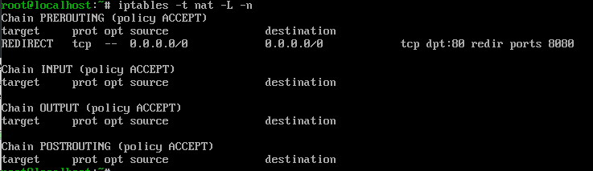

One command can work with this is date && sudo tshark -i enp0s3 -Y ”ip.src == 192.168.1.96 && tcp.port == 80” -c 10
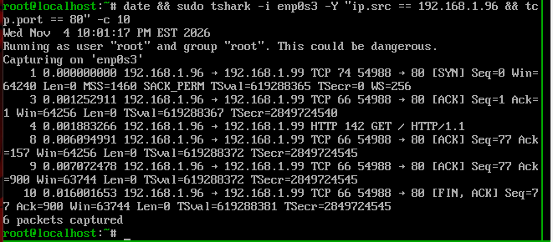
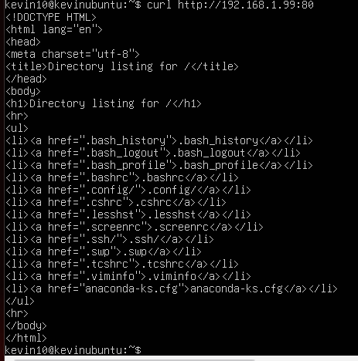
In my other server I run the command curl http://192.168.1.99:80
/sbin/iptables -L -v -n --line-numbers List the rules and the list of your firewall.
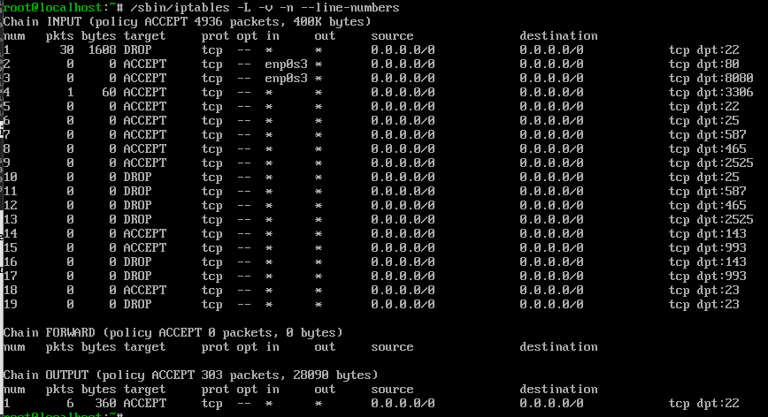
/sbin/iptables -D INPUT 2 Used this to delete a firewall rule after typing something by accident.
iptables -t nat -D PREROUTING 1 and this one is for deleting routings. Just in case you typed the same twice by accident.

2. Deal with MySQL service (open needed ports)
The default port for MYSQL is 3306 which is used by the same client, connectors, and utilities. Btw MYSQL is an abbreviation of database. Unless we have something here, we are not getting anything. I will display the port of course.
I decided to use this as an easy method of displaying this port.

The command is iptables -A INPUT -p tcp --dport 3306 -j ACCEPT
iptables -L -n
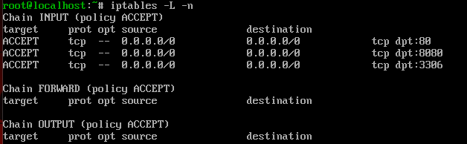
The command is date && sudo tshark -i ens0s3 -f "tcp port 3306" -c 4 The command works to display the port. Sadly, I am not getting anything. I will try pinging the port instead.
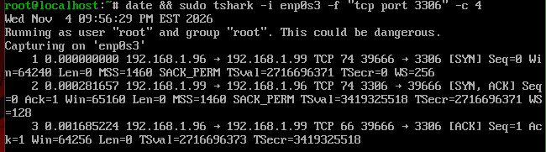
I capture 4 packages from the other server request.
firewall-cmd --zone=public --permanent --add-port 3306/tcp
Make sure to reload the firewall.
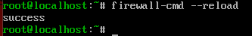
firewall-cmd --list-all to make sure it worked
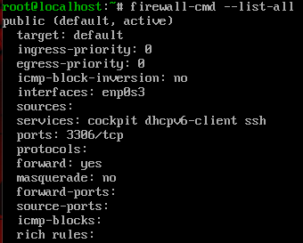
This should give us what we need to work with those ports.
Ping 192.168.1.99 3306 I used this command to ping my port 3306. We just needed the Ip of our server and the desired port to be pinged.
I ping with my other server
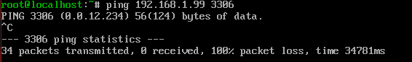
3. Deal with SSH service (allow incoming and outgoing SSH, second script to deny SSH)

Let’s start with the basics then. SSH is a protocol for securely exchanging data between two computers over an untrusted network. We will allow first the incoming and outgoing SSH.

To allow incoming traffic from SSH :
iptables -A INPUT -p tcp --dport 22 -j ACCEPT Asking permission before the execution
To allow outgoing traffic from SSH:
iptables -A OUTPUT -p tcp --dport 22 -j ACCEPT
Now let’s Deny SSH.
iptables -I INPUT -p tcp --dport 22 -j DROP
We use Drop to discharge all traffic. -I It is used to insert a new rule instead of overwriting it like what could happen when you append something, for example using this with -A. With this anybody who tries to abuse this port could be stopped.

Here we have evidence of dropping the port 22 that is SSH.
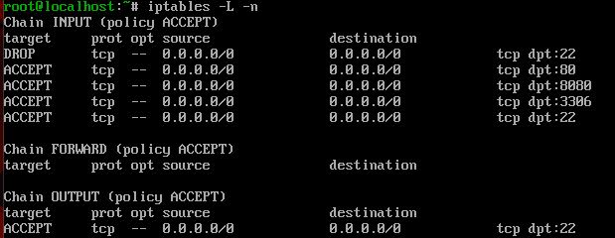
I used telnet 192.168.1.99 22 to ping the port.
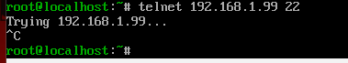
I run the command date && sudo tshark -I enp0s3 -Y “ip.src == 192.168.1.96 && tcp.port == 22” -c 3
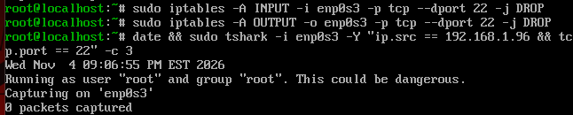
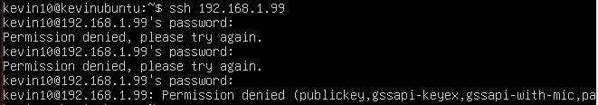
So the rule works and the ssh is blocked.
4. Deal with Email service (Such as allow or block incoming SMTP,POP3...)
There are a couple of ports here that allow SMPT ports. These ports are 25, 587, 465, 2525.

To allow incoming traffic from SMTP:
iptables -A INPUT -p tcp --dport 25 -j ACCEPT
iptables -A INPUT -p tcp --dport 587 -j ACCEPT
iptables -A INPUT -p tcp --dport 465 -j ACCEPT
iptables -A INPUT -p tcp --dport 2525 -j ACCEPT

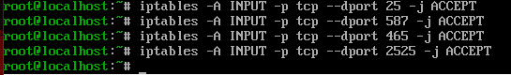
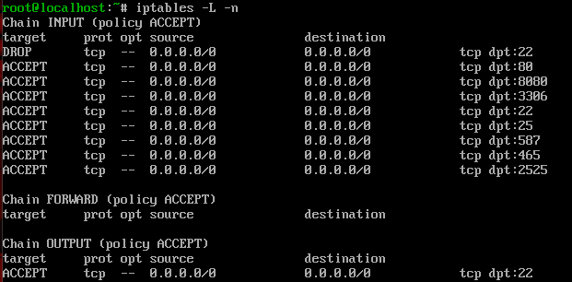

To Block incoming traffic from SMTP:
iptables -A INPUT -p tcp --dport 25 -j DROP
iptables -A INPUT -p tcp --dport 587 -j DROP
iptables -A INPUT -p tcp --dport 465 -j DROP
iptables -A INPUT -p tcp --dport 2525 -j DROP
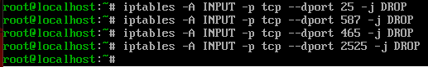
This is how we allow and block that traffic for the email service. Luckily, we don’t have to add the ports like the 8080 or 3306. Now let’s check if these ports receive any signal.
I always run tshark but as I said. I don’t have any kind of traffic. But I can ping the ports like in the other examples to ensure they are listening to the request. But instead in this one I will list it with the rules in the iptable.
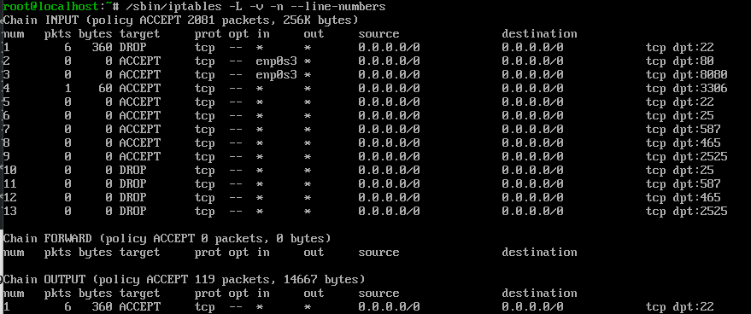

POP3
This is also for mail services. For this the ports are 143 and 993.So then, Let’s start with allowing the traffic from these ports.
iptables -A INPUT -p tcp --dport 143 -j ACCEPT
iptables -A INPUT -p tcp --dport 993 -j ACCEPT
To block Incoming traffic:
iptables -A INPUT -p tcp --dport 143 -j DROP
iptables -A INPUT -p tcp --dport 993 -j DROP
4.Script to allow/block specific hosts, MAC addresses
Let’s say there is a specific user trying to do something malicious. How do I block them then? That would be easier than you think. Let’s say am the one doing it. I would grab the Ip of the user and block it from sending traffic.

iptables -I INPUT -s 123.456.789.1 -j DROP This Ip is an example. Just Write a regular Ip and works.

How to allow incoming connection from a specific host

iptables -I INPUT -s 123.456.789.1 -j ACCEPT Same Here. This Ip are examples.

To Block specific MAC addresses:
iptables -A INPUT -o enp0s3 -m mac --mac-source 08:00:27:58:7B:77 -j DROP

To use the MAC address function, we must type: -m mac and --mac-source to specify what the MAC source is.
To Allow specific MAC addresses:
iptables -A INPUT -I enp0s3 -m mac --mac-source 08:00:27:58:7B:77 -j ACCEPT

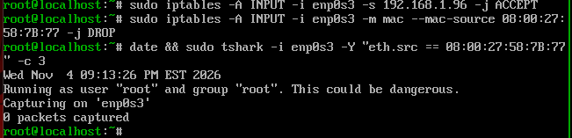

6.A script/command to block telnet, block ping
The port 23 is telnet by default.

This is for allowing telnet communication.
iptables -A INPUT -p tcp --dport 23 -j ACCEPT

How to block incoming telnet communication.
iptables -A INPUT -p tcp --dport 23 -j DROP
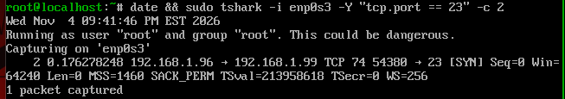
How to disable ping request.
iptables -A INPUT -p icmp --icmp-type echo-request -j REJECT
The ping request uses ICMP packages.

To allow back the ping request we use this command.
iptables -D INPUT -p icmp --icmp-type echo-request -j REJECT
The -D function will delete the previous rule allowing us to establish the ping command again.
7. Use Wireshark to show that your statements/scripts are working properly on BOTH servers.

8. Write the specs for how you think you could prevent a DDOS attack using Iptables. Can you write a script for this?

Let’s start with some basics here. I will ping myself to see how my server is doing so far. To do that. I type ping followed with my Ip. In this case ping 192.168.1.99

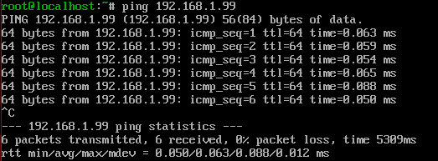
Everything seems normal so far. But let’s say someone could be trying to perform an attack through my ports. I will use the following commands or rules to stop a couple of basic and most common DDOS attacks.

/sbin/iptables -A INPUT -p tcp --destination-port 80 -j DROP This one is for dropping the port 80. Http cross through this port.
iptables -t mangle -A PREROUTING -p icmp -j DROP This drops all ICMP packets. ICMP is only used to ping a host to find out if it’s still alive. With this I will stop slowing the network so far. But there are others that could help me a little more with this.
iptables -t mangle -A PREROUTING -f -j DROP For example, this one is for blocking fragmented packages.
iptables -t mangle -A PREROUTING -m conntrack --ctstate INVALID -j DROP This rule blocks all packets that are not a SYN packet and don’t belong to an established TCP connection.
iptables -A OUTPUT -p udp -j DROP This one for dropping udp traffic.

So, let’s get into context. I imagine myself working with my server when I detect some slowing down with the traffic on my network. I will execute a script runed with the previous commands to stop the most common DDOS attacks. It could be another type, but I believe this that I presented would fit more in the common terms. Hopefully by dropping those fragmented packages, ping connections, udp traffic and else. My network would establish itself in a steadier way.

References
https://linuxconfig.org/install-wireshark-on-linux-redhat-8
https://linuxhint.com/wireshark-command-line-interface-tshark/
https://www.wireshark.org/docs/man-pages/tshark.html
https://www.wireshark.org/docs/wsug_html_chunked/ChCustCommandLine.html
https://www.cyberciti.biz/faq/how-to-list-all-iptables-rules-in-linux/
https://serverfault.com/questions/320614/how-to-forward-port-80-to-another-port-on-the-samemachine
https://www.cyberciti.biz/faq/deleting-firewall-rules/
https://serverfault.com/questions/159544/undoing-port-forwarding
https://dev.mysql.com/doc/mysql-port-reference/en/mysql-ports-reference-tables.html
https://serverfault.com/questions/610332/iptables-allow-outgoing-ssh
https://www.thegeekstuff.com/2011/03/iptables-inbound-and-outbound-rules/
https://www.sparkpost.com/blog/what-smtp-port/
https://www.digitalocean.com/community/tutorials/iptables-essentials-common-firewall-rules-and-commands
https://docs.rackspace.com/support/how-to/open-ports-in-the-linux-firewall-to-access-pop-and-imap-mail-servers/
https://www.cyberciti.biz/tips/howto-block-ipaddress-with-iptables-firewall.html
https://unix.stackexchange.com/questions/11851/iptables-allow-certain-ips-and-block-all-other-connection
https://serverfault.com/questions/519480/iptables-allow-access-from-certain-mac-addresses
https://tecadmin.net/mac-address-filtering-using-iptables/
https://unix.stackexchange.com/questions/207697/how-to-block-telnet-using-iptables-command
https://tecadmin.net/block-ping-responses-in-linux/
https://www.layerstack.com/resources/tutorials/How-to-enable-and-disable-Ping-from-IPTables-on-Linux-Cloud-Servers
https://www.crybit.com/prevent-dos-attack/
https://serverfault.com/questions/583523/linux-command-to-prevent-dos-attack-by-using-netstat-and-iptables
https://www.agix.com.au/stop-ddos-attack-using-iptables/
https://devconnected.com/how-to-ping-specific-port-number/
https://linuxconfig.org/redhat-8-open-and-close-ports
https://docs.rackspace.com/support/how-to/block-an-ip-address-on-a-Linux-server/
https://www.youtube.com/watch?v=eZYtnzODpW4&ab_channel=NetworkChuck
https://javapipe.com/blog/iptables-ddos-protection/

